SUMMERVILLE CREDIT UNION · CONSOLIDATED MEMBER GUIDE · CSUM-03 of 30
Account Overview & Transaction History

Module: nFinia Digital Banking > Accounts
Sources: Summerville Reports Series A (36 docs) + Series B (25 docs) | Features: nFinia Documentation Features Spreadsheet
01 PRODUCT SUMMARY

The Account Overview is Summerville Credit Union members' consolidated portfolio view within the nFinia digital banking platform. Accessed by clicking 'Accounts' from the top navigation on the Dashboard, this page displays all of the member's active accounts — Checking, Savings, Loans, Certificates of Deposit, Lines of Credit, and Membership accounts — as a structured list. Each entry presents the account name, masked account number, current balance, and available balance.
Clicking any account tile navigates to the full Account Detail page for that account. From the Account Detail, members can view complete transaction history, search and filter transactions by date, amount, or description, export or print history, and access related services like eStatements, scheduled transfers, and stop payment requests.
The Transaction Search feature allows members to find specific transactions across all accounts using criteria including date range, amount range, transaction type, and text search of descriptions. Search results can be exported to CSV for record-keeping or accounting purposes.

At a Glance

Attribute | Detail
Module | nFinia Digital Banking > Accounts
Account Types Shown | Checking, Savings, Dividends, Money Market, CD, Loans, Lines of Credit
Transaction History | Searchable, filterable, exportable
Account Actions | Check Deposit, Stop Payment, eStatements, Direct Deposit Form
Related Links | eStatements, Scheduled Transfers, Change Password, Download Statements
Related Reports | CSUM-04 (Account Detail), CSUM-05 (eDocuments), CSUM-19 (Online Forms)

02 KEY USE CASES

Use Case | Who Uses It | What They Do | Business Value
View All Balances | Members checking all account balances | Navigate to Accounts to see all account balances at once | Single screen replaces multiple branch inquiries
Find a Transaction | Members researching specific charge | Open account detail, use Transaction Search with description or amount | Self-service transaction research eliminates support calls
Export Transaction History | Members needing data for taxes or budgeting | Use Export Feature to download CSV of transaction history | Provides machine-readable data for external accounting tools
Check Account Numbers | Members needing routing/account number | Open account detail to see masked and full account info | On-demand access to banking numbers without calling the CU
Manage Certificate CD | Members with maturing certificates | Access certificate account detail to renew, close, or change terms | Self-service certificate management without branch visit

03 STEP-BY-STEP GUIDE

Navigation: Dashboard > 'Accounts' link in top navigation bar.

Step 1 — Start from Dashboard
The member begins at the Dashboard after logging in. The Dashboard displays all account balances, upcoming payments, quick-action tiles, and the top navigation bar with links to Accounts, Move Money, and More.
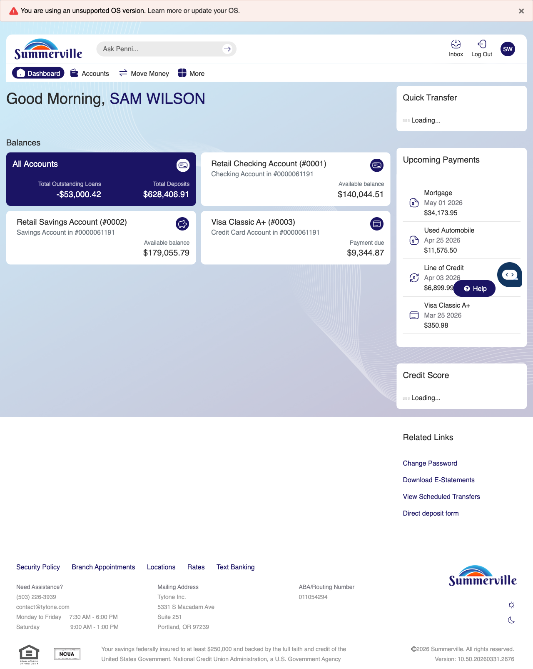
Step 1: Start from Dashboard

Step 2 — Open the More Menu
The member clicks ‘More’ in the top navigation bar. The More options panel expands to show additional features: Check Deposit, User ID and Password, eDocuments, Account Alerts, General Alerts, Password, Forms, One-Time Passcode, Skip A Pay, Do-Not-Disturb, Manage Devices, My Insights, Alert Settings, Recent Activities, and Card Services.
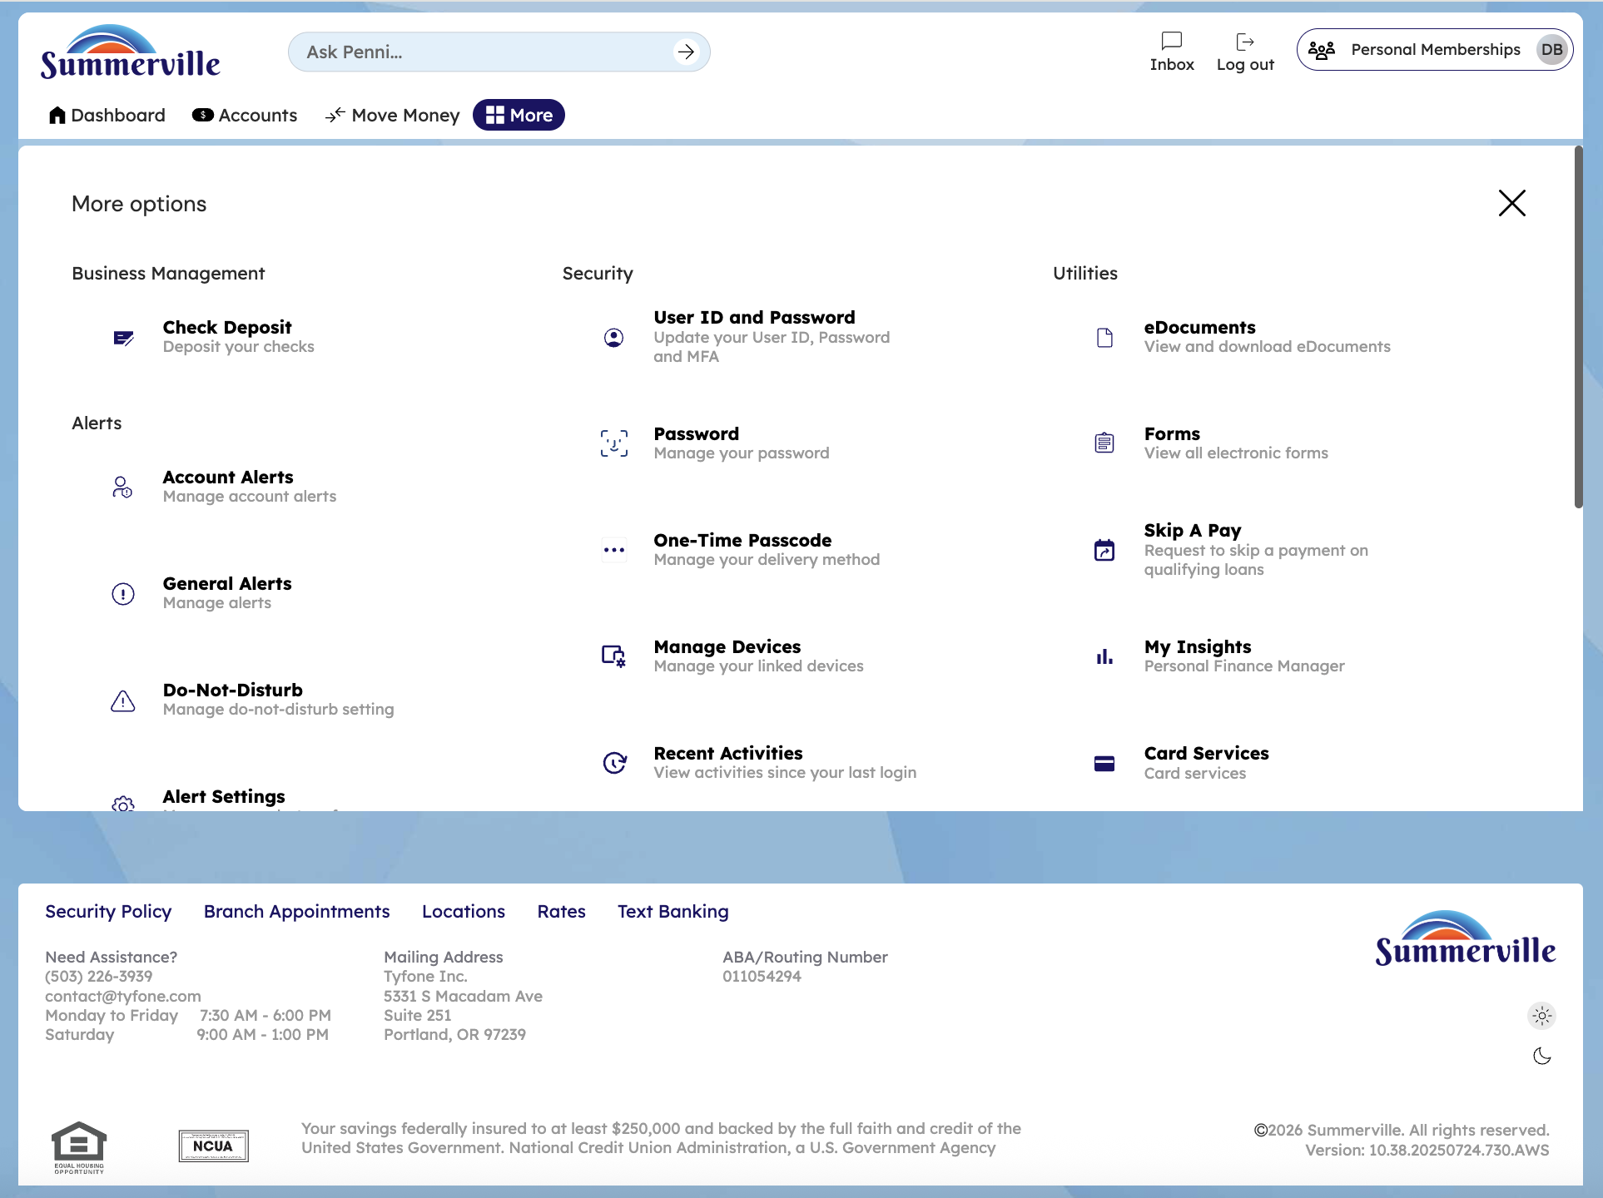
Step 2: More Menu

Step 3 — Navigate from Dashboard to Accounts
The Account Overview page is displayed showing a compact list of account cards. Each card shows the account name and current balance in a condensed view.
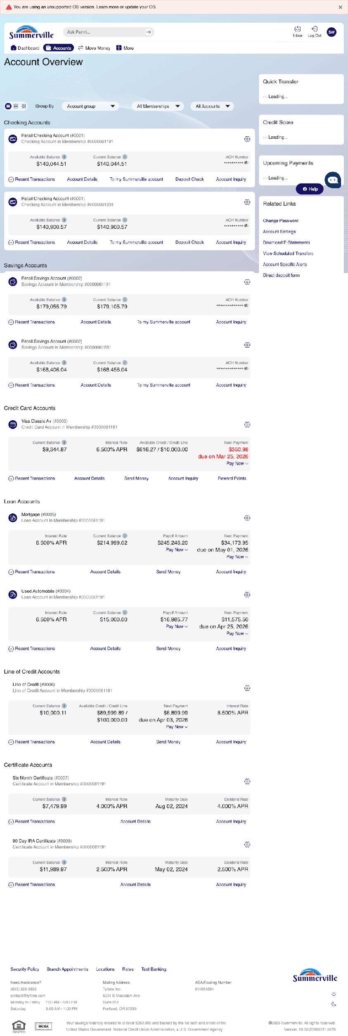
Step 3: Navigate from Dashboard to Accounts

Step 4 — Scroll Full Account List
The complete Accounts page is shown with all account types organized by category — checking, savings, credit cards, and loans — each displaying their current balances and action links.
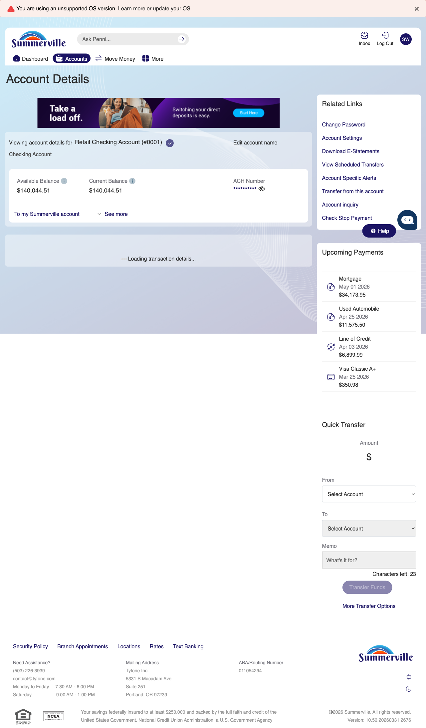
Step 4: Scroll Full Account List

Step 5 — Open Checking Account Detail
The Retail Checking Account detail page is displayed, showing the available and current balance, ACH number, and a transaction list with multiple entries including dates, descriptions, amounts, and running balances.
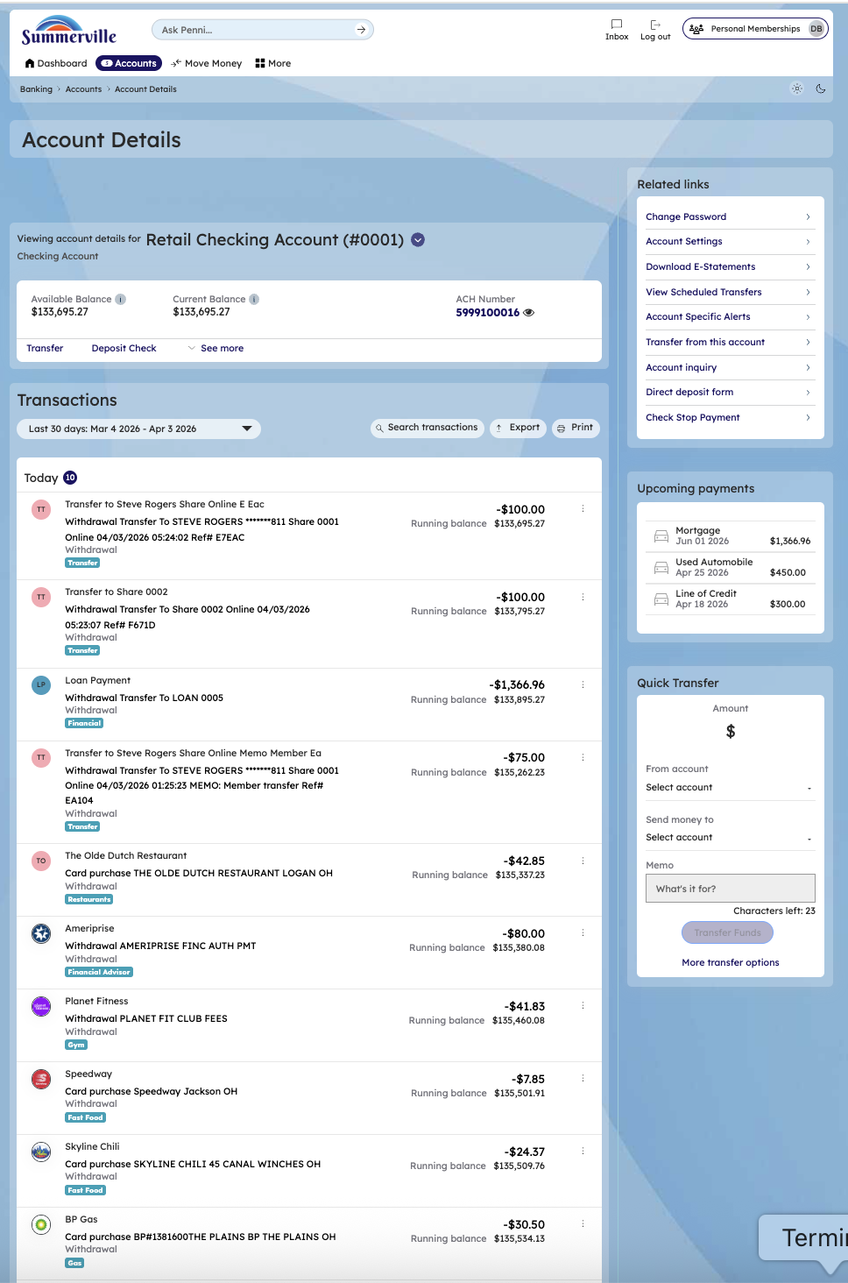
Step 5: Open Checking Account Detail

Step 6 — Open Savings / Dividends Account Detail
The checking account detail page continues, showing the transaction list with transfer and deposit transactions. Each entry displays the date, description, amount, and running balance.
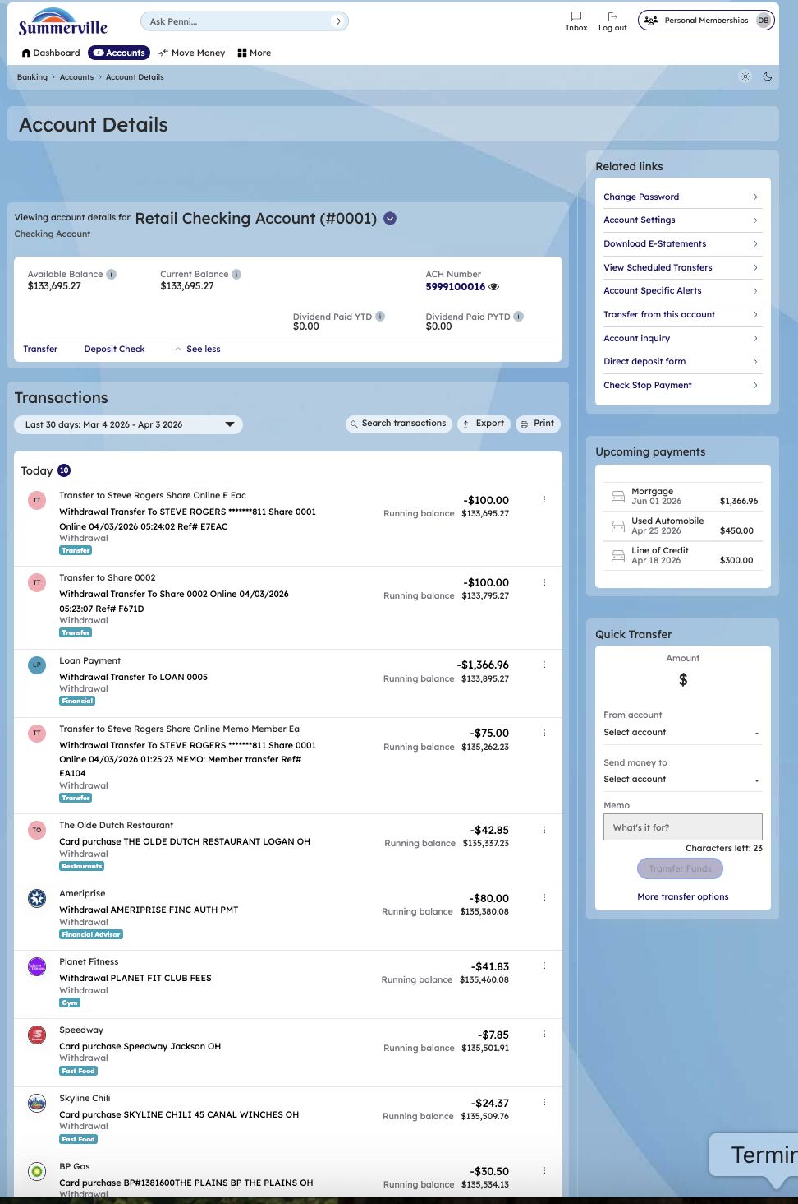
Step 6: Open Savings / Dividends Account Detail

Step 7 — View All Account Types Overview
The Account Overview page shows all account types grouped by category — checking, savings, credit card, and loan — with balances and quick action buttons displayed for each account.
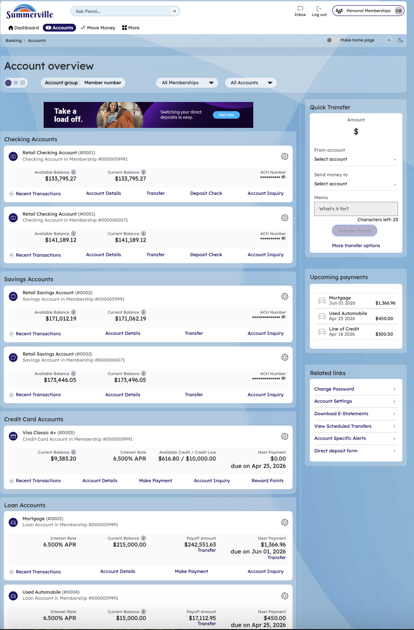
Step 7: View All Account Types Overview

Step 8 — Access Related Links & Services
The full-page account overview is shown with all account categories, a promotional messaging banner, and a right sidebar containing Related Links and upcoming payments information.
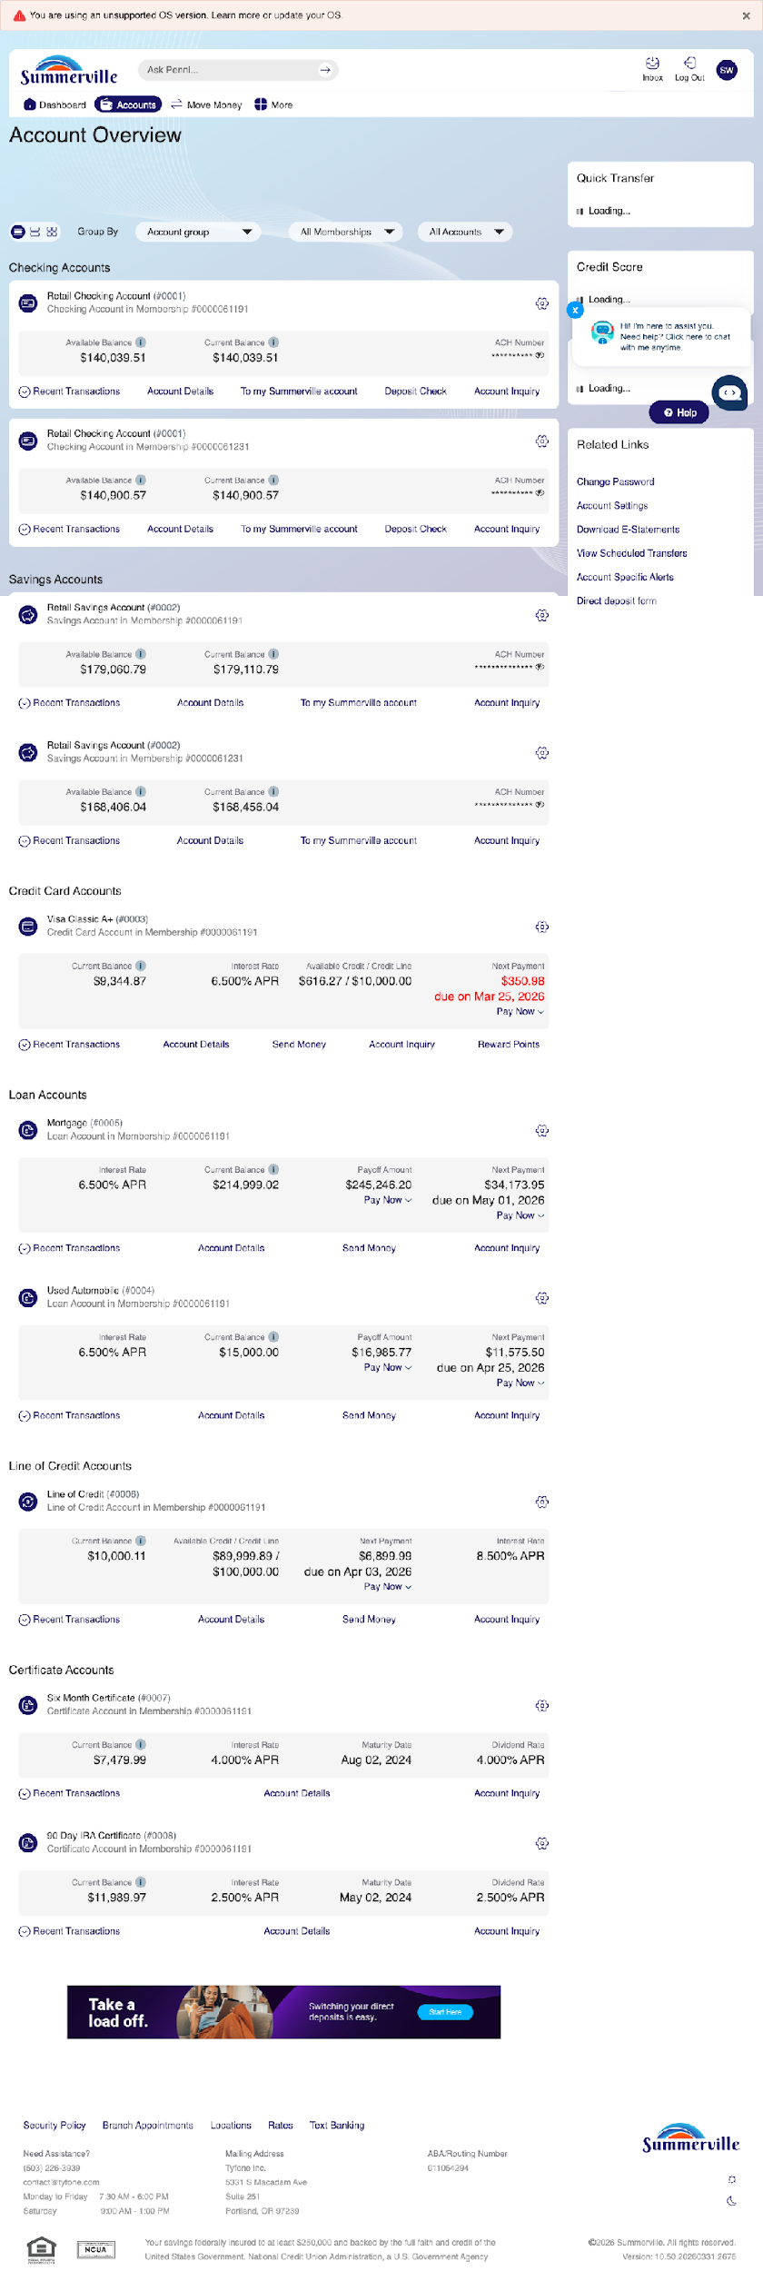
Step 8: Access Related Links & Services

Step 9 — Check Deposit from Account Detail
The Check Deposit page is displayed with a 'Check Deposit' header and a blue informational banner promoting direct deposit services. The deposit interface is accessible from this screen.
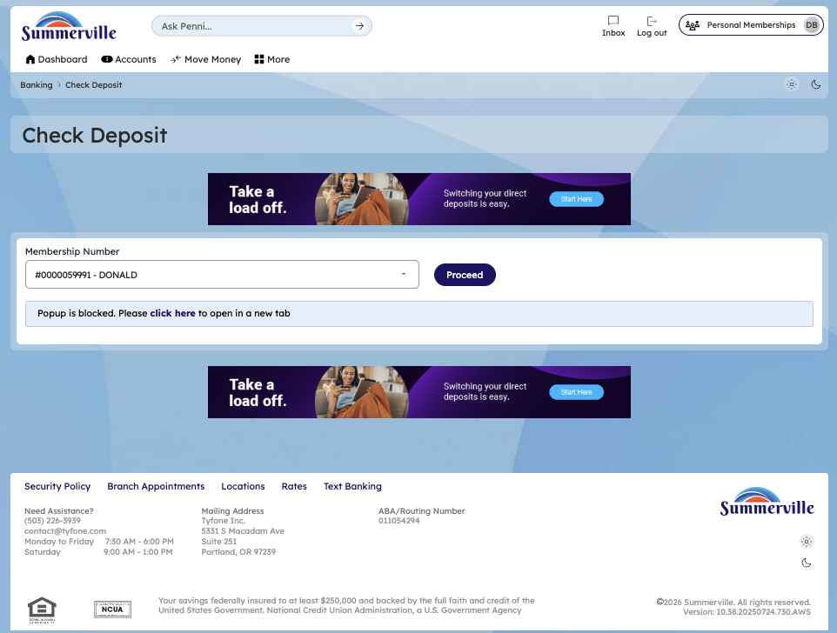
Step 9: Check Deposit from Account Detail

Step 10 — Check Deposit — Select Membership
The Check Deposit page shows a membership selection dropdown listing multiple membership accounts, each identified by number and name, for the member to select before depositing a check.
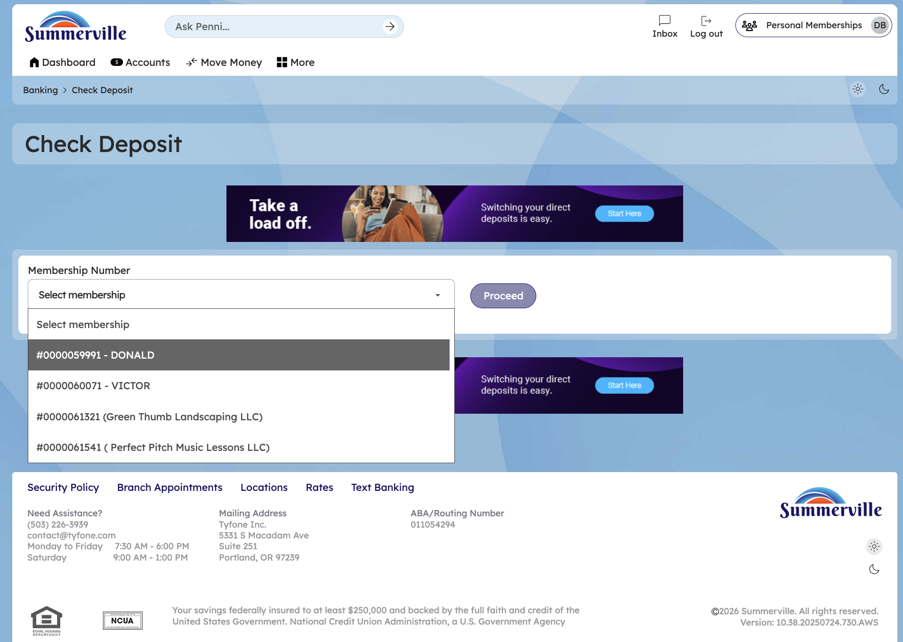
Step 10: Check Deposit — Select Membership

Step 11 — Check Deposit — Ensenta Welcome
The Ensenta remote deposit welcome screen is displayed, explaining the three-step deposit process: Select Account, Upload Check Images, and Confirm Deposit.
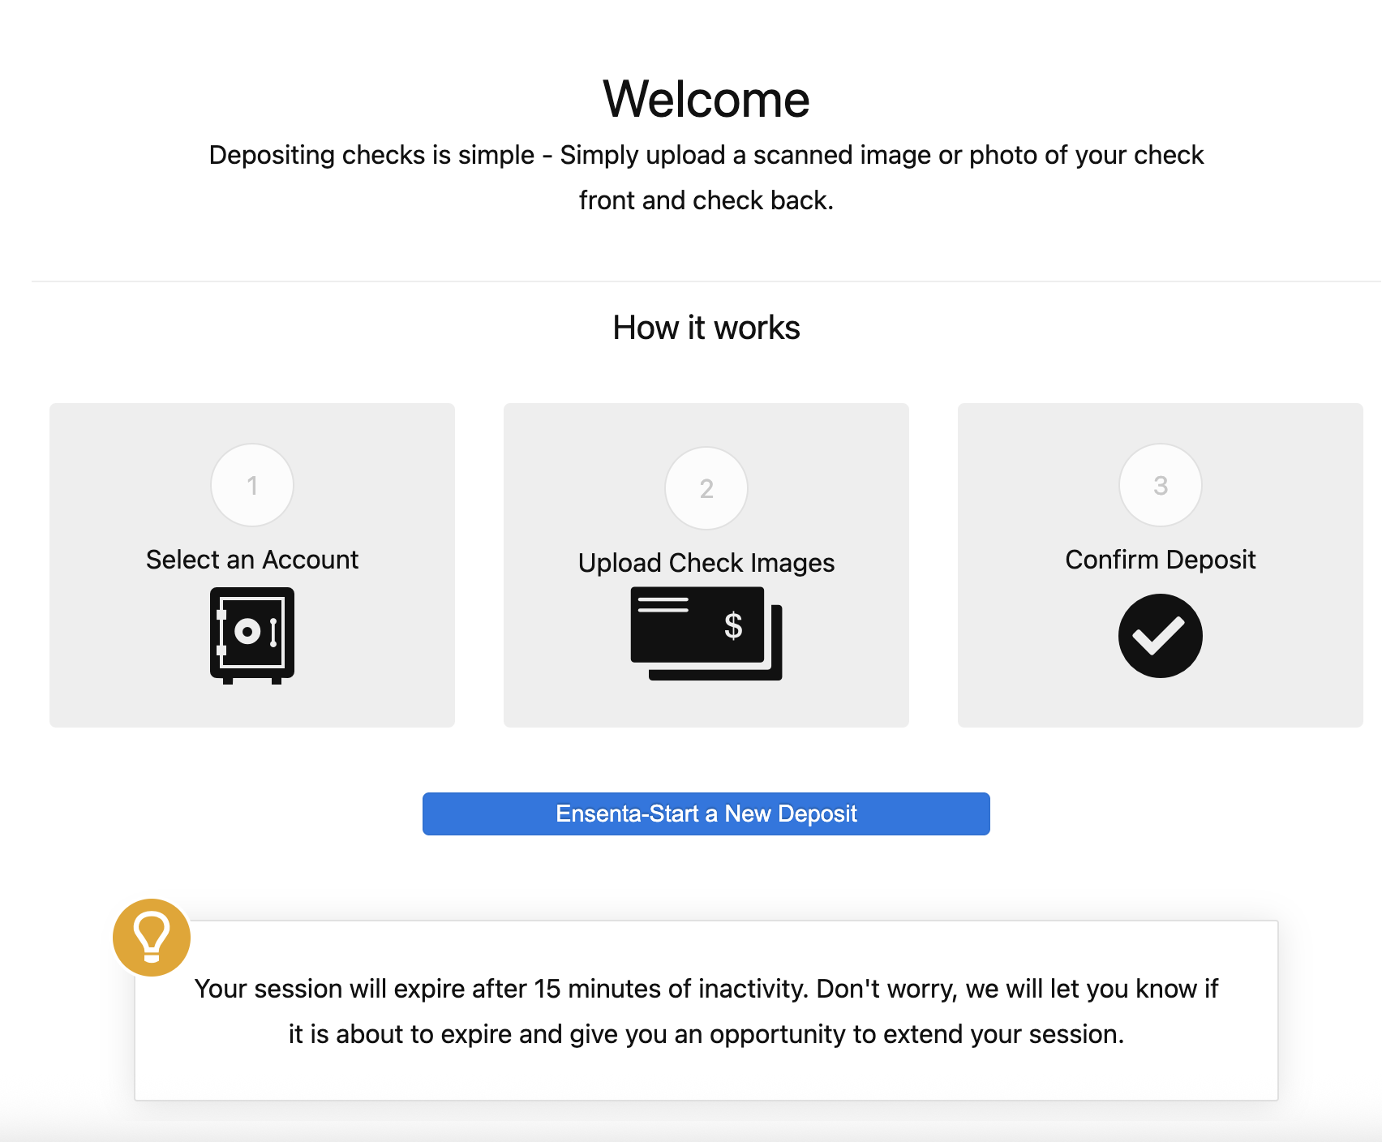
Step 11: Check Deposit — Ensenta Welcome

Step 12 — Check Deposit — Enter Amount & Upload Images
The check deposit form is shown with fields for selecting the account and entering the check amount, plus upload areas for capturing the check front and back images.
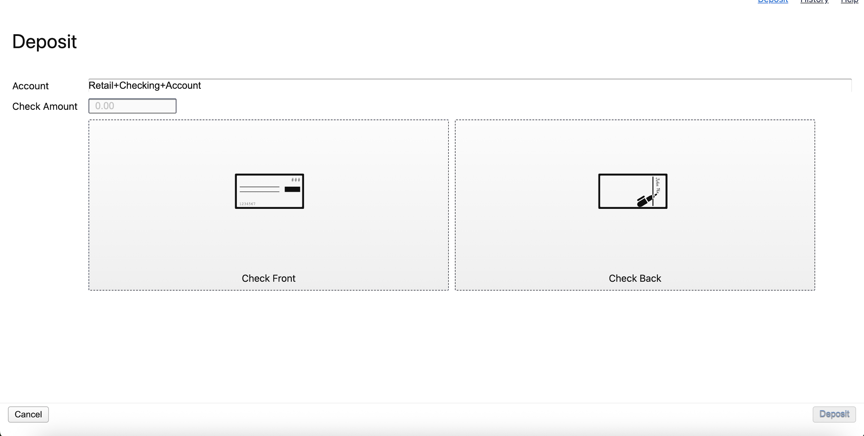
Step 12: Check Deposit — Enter Amount & Upload Images

